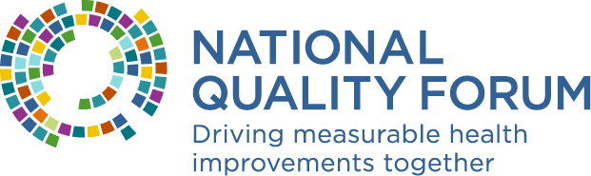

Easy Ways to Share The Care We Need
Thank you for helping us get the word out about this important resource. The entire NQF team is excited to promote The Care We Need so that every person, in every community, consistently and predictably receives high quality care by 2030.
- If you’re not already, please follow NQF on Twitter and LinkedIn and like, share and/or retweet NQF’s social media posts on both platforms promoting the Task Force report.
- Use the sample posts below on your personal, professional, or organization Twitter and/or LinkedIn accounts. Or you can use the samples below as a guide and draft your own posts for sharing the report. If possible, please include the campaign hashtags and please tag NQF in your posts.
#CareWeNeed
#BetterHealthOutcomes
#DrivingQuality
- Please don’t hesitate to let us know if you have questions about tagging NQF in posts or using hashtags!

Sample Posts
Feel free to use these posts as written or personalize and edit so they reflect your unique voice and style. Please tag NQF in your posts (Twitter: @NatQualityForum and LinkedIn: @National Quality Forum) and use the campaign hashtag (#CareWeNeed) so we can share them and amplify your posts.

Twitter
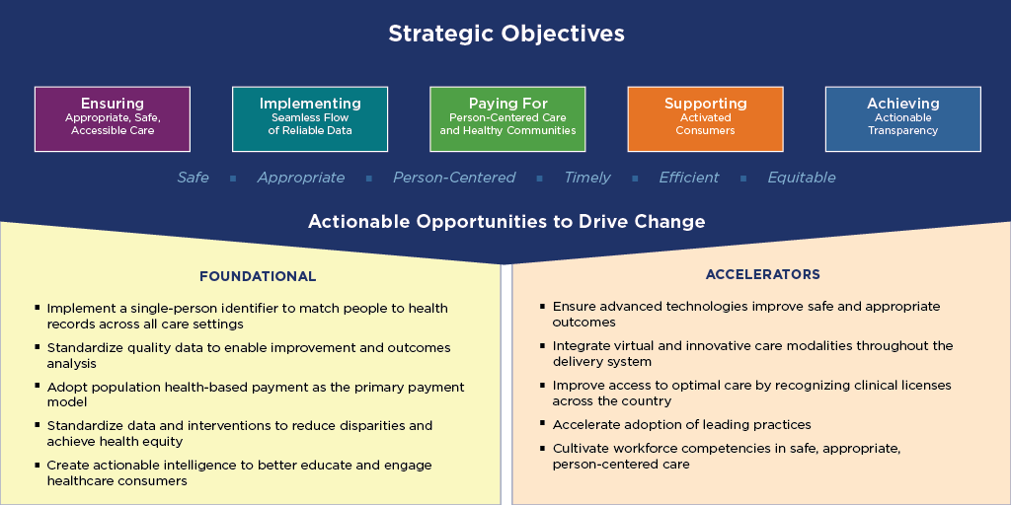
We are already seeing many recommendations for achieving #BetterHealthOutcomes being implemented in response to #COVID19. The latest report from @NatQualityForum discusses how to ensure every person receives safe, person-centered care by 2030. #CareWeNeed https://bit.ly/2VduvGF [SAMPLE IMAGE BELOW]

The #COVID19 pandemic highlights both the strengths and weaknesses in America’s healthcare delivery system. The #CareWeNeed from @NatQualityForum provides a roadmap to overcome the most critical challenges in healthcare for #BetterHealthOutcomes https://bit.ly/2VduvGF [SAMPLE IMAGE BELOW]
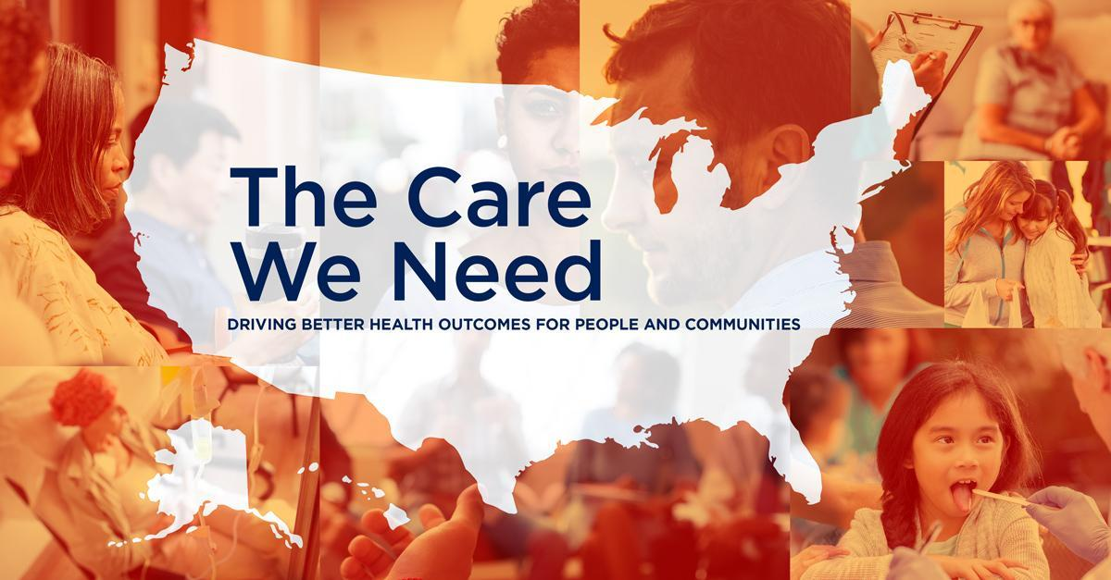

LinkedIn
The #COVID19 pandemic highlights both the strengths and weaknesses in America’s healthcare delivery system. Now is the time to normalize the processes and practices that reliably deliver safe, appropriate, person-centered care. The National Quality Task Force convened by @National Quality Forum [TAG: https://www.linkedin.com/company/national-quality-forum] has released recommendations to ensure that every person, in every community, consistently and predictably receives high quality care by 2030. I hope you’ll read and share the recommendations in The Care We Need: Driving Better Health Outcomes for People and Communities. https://bit.ly/2VduvGF #CareWeNeed #BetterHealthOutcomes #DrivingQuality [SAMPLE IMAGE BELOW]

Now, more than ever, it is crucial to address the challenges our healthcare delivery system faces. I believe that every person, in every community, should get high value care. The National Quality Task Force convened by @National Quality Forum [TAG: https://www.linkedin.com/company/national-quality-forum] recently released a report providing a clear roadmap to making this goal a reality. Visit the site to learn more about how we can achieve #BetterHealthOutcomes for all! #CareWeNeed https://bit.ly/2VduvGF [SAMPLE IMAGE BELOW]

